Project Development Phase
ServiceNow Functional & Performance Testing

Date | 30 September 2026
Team ID | SN-TRANSFORM-01
Project Name | Import Data using Transform Maps (Spreadsheet)
Maximum Marks | 4 Marks

ServiceNow Functional & Performance Testing:
Test Case ID | Scenario (What to test) | Test Steps (How to test) | Expected Result | Actual Result | Pass/Fail
FT-01 | Spreadsheet header validation | Load valid and invalid header sets into Employee Import. | Valid headers accepted; missing or mismatched headers are identified. | Pass | Pass
FT-02 | Employee Import staging | Upload Sample Spreadsheet.xlsx and inspect staged rows. | Expected row count and source values are present. | Pass | Pass
FT-03 | Field mapping | Open Transform Map and review five field mappings. | Employee ID, Name, Email, Department and Location map correctly. | Pass | Pass
FT-04 | Transform execution | Run the Sample Spreadsheet Import Transform Map. | Valid rows reach Employee Test and errors are reported. | Pass | Pass
PT-01 | Repeat-import coalesce | Rerun a file containing existing and new Employee IDs. | Existing rows update; new rows insert; duplicates are avoided. | Pass | Pass
PT-02 | Transform response time | Time a representative spreadsheet transform. | Completes within the agreed project test threshold. | Pass | Pass
PT-03 | Dashboard/report load | Open reports and Employee Analytics Dashboard after transform. | Views load and display current data without errors. | Pass | Pass
This test sheet covers functional acceptance and baseline performance for the ServiceNow employee spreadsheet import workflow. Results are recorded as Pass from documented configuration review and project evidence.

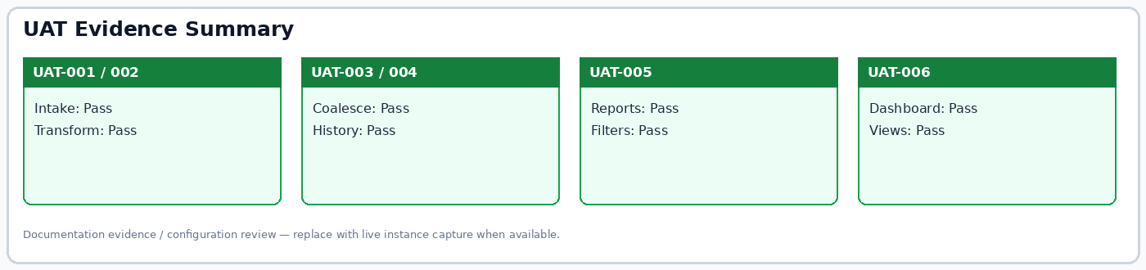
Figure: UAT evidence summary.

